**User Manual:**

1. **Product Overview**

Our product is a place where people become friends or find their friends so they can communicate with one another and a social gathering where you can see what your friends statuses which can lead to conversation amongst each other, see what their thinking about or opinions on certain issues or drop a funny joke to make your friends laugh. Our web application aims to be for everyone and not just a selective group; we want everyone to meet new people, have social interaction with one another that could be somewhat difficult with our busy lives, and bring a user something fresh and new compared to the other social/chat applications like WeChat or WhatsApp. To give the user this new experience, we came up with the main functions that will make it happen. We have everything from being able to add a user, lookup an existing user, delete a user from your contact list, send messages to your friends, view chat history, accept/deny friend requests, block certain users, customize/set your profile, post statuses and view your friend statuses.

1. **Getting Started**
2. Landing page

The landing page has three basic functions that the user will use, which are login, register, and the forget password page, as well as the introduction of our chatting web application in the left side of the web page.

* 1. Login

There are empty text blocks for the user to type in their username, and password, once the user clicks the login button, the system will check it through the database, if they all match the user will be redirect to the main chatting page, and if the user types in the wrong username or password, the system will alert the user that they need to re-enter their username and password.

* 1. Register

The user can click the register button to register their own account, once they clicked the register button, the application will redirect the user to the register page, which allows the user to make their own username, password, and profile picture. For the password part, the user needs to type twice for confirmation purpose. And they need to follow certain rules to make their password. There should be a back button for the user to get back from the register page to the landing page.

* 1. Forget password

The user can click the forget password to get their password back, after they click the forget password button, the user will be redirect to the forget password page, and after they enter their username on the empty text block, the system will send out email to let the user change their password through that email.

1. Main chatting page

The main chatting page allows the user to see their contact list, their chat window, and the ability to go to profile page, as well as log out.

* 1. Contact list

The contact list feature is in the left side of the whole main page, users can see their friend lists, and by clicking the add button on the top, users can add new contact through searching other users’ username. By clicking each contact, the application will pop out the chatting window.

* 1. The main chatting window

The main chatting window will have empty space in the bottom for the user to type in text. By clicking the send button, the user should able to send the message to other user. Also, there are buttons for sending pictures, files, (voice message, video chat). The user can do group chat by clicking the add in the chatting window and add other user from the contact list.

* 1. Other buttons

By clicking the log out button, the application will log the user out, and redirect the user back to the landing page; and by clicking the profile button, the user will be redirected to the profile page.

1. Profile page

The profile page allows the user to change their display name, and their password, and change the profile picture by clicking each button, and also the user can log out through the log out button. And the application will redirect the user back to the landing page.

**3. Modes of Operation**

Chatting web app

To chat in the system, the user must complete the following steps. First, need have an account and type in the username and password and login to the main chatting page. Next, click the friend/contact the profile to start a message. For each contact, it has own chatting pages. See the steps blow for a more detailed description,

The user who don’t have an account need to register an account by an unused username.

* 1. At the login and register screen pictured below, at get started click the textbox titled “Name” and type your username. And type your email under the email. Then click into the box titled “Password” and type your password. And the if the user ready the I agree the term by click box and click sign up. Finish create the personal account.

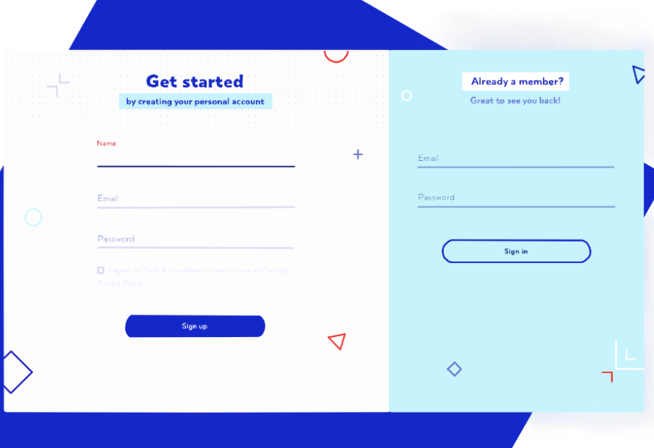

The user who have an account in the system need to login into the system by right password and username.

* 1. At the login screen pictured below, click into the textbox titled under the “Already a member” “Username” and type your username. Then click into the box titled “Password” and type your password. Complete the login process by clicking the button titled “Sign in.” And it bring you to the main chatting page.



2. At the main chatting page on the left side there contact button, click it and it will show users contactors choose contactor that user need to chat with. 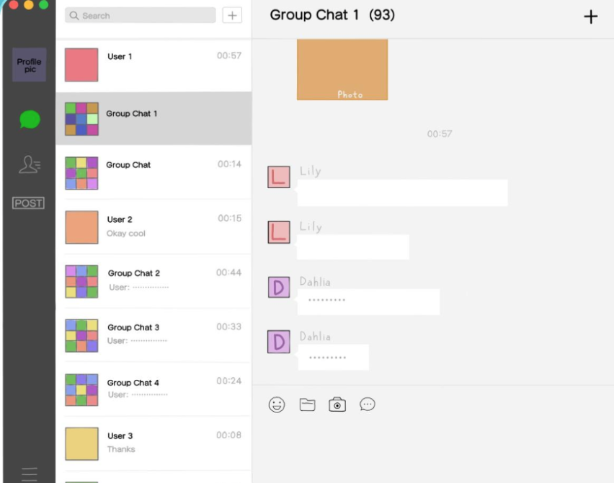 



3.After the choose the user that you want to contact, and the user you choose will pop up the first one on your recent connection list. And you can chat the current user that you choose. And you can click to other recent chatting group or people in middle slide bar and chat with them.





You want chat with the them click the text field at the right bottom place and hit enter or send button to send the message to your friend.

4.You can quit the login session by click the top left red button to logout of the chatting system. The quit button will return you to the login pages. If you login by different computer, the chatting history only last for 7 days.